**Documentation- Historical Fundamental Screener**

**Introduction:**

The HFS is a stock research tool whose functionality is as simple as it gets. Filter stocks based on financial ratios (Up to 5 of them as of now), rank them by a certain ratio, select the size of your portfolio and see how the strategy would have performed over the last 10 years. If you are not satisfied with the ratios primarily available, you can create up to 5 new ratios per back-test and filter the stocks based on them.

**Index**

1. **Overview of the App**
2. **Description of the Financial Ratios and Other variables from the financial statements**
3. **Strategy description**
4. **Data - source and reliability**
5. **Overview of the App**

You can click on the checkboxes that say ‘I want to create a new ratio’ to create a new ratio based on the pre-existing ratios and other variables. Refer **Part2** for details regarding the individual ratios and variables. The syntax for creating a new ratio in this app, is the same as that for creating a new column in a Pandas data frame named ‘data’.

Example:

If you want to create a new ratio that divides the Sales by the Share Capital, click on the checkbox for creating a new ratio and then,

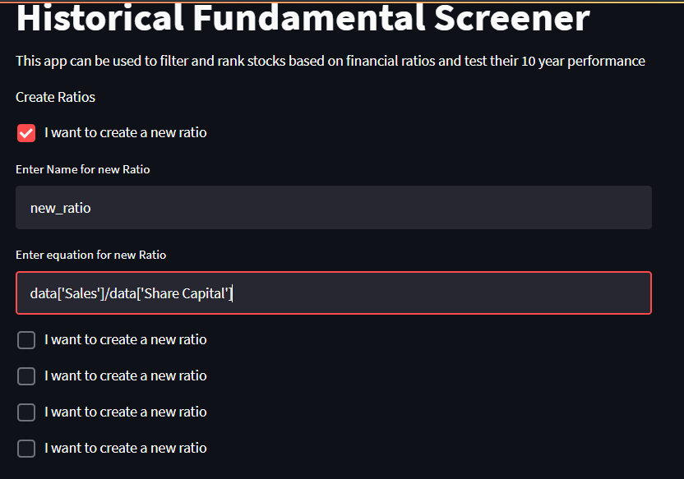

You can follow the same procedure for up to 5 new ratios. Note that only one new ratio can be added per checkbox. Incorrect syntax used could lead to errors. Also proceed in an orderly way with the checkboxes to avoid errors.

Once you are done adding ratios, proceed to the SELECTION CRITERIA to start filtering companies.

Ideally, you should take a look at the SELECTION CRITERIA section first to know the Ratios and variables that are available to you primarily.

If you want to select stocks that have a Price to Earning (PE) of less than 10 and rank them based on their EPS_growth and choose the top 10 stocks, you can check its performance by doing the following:

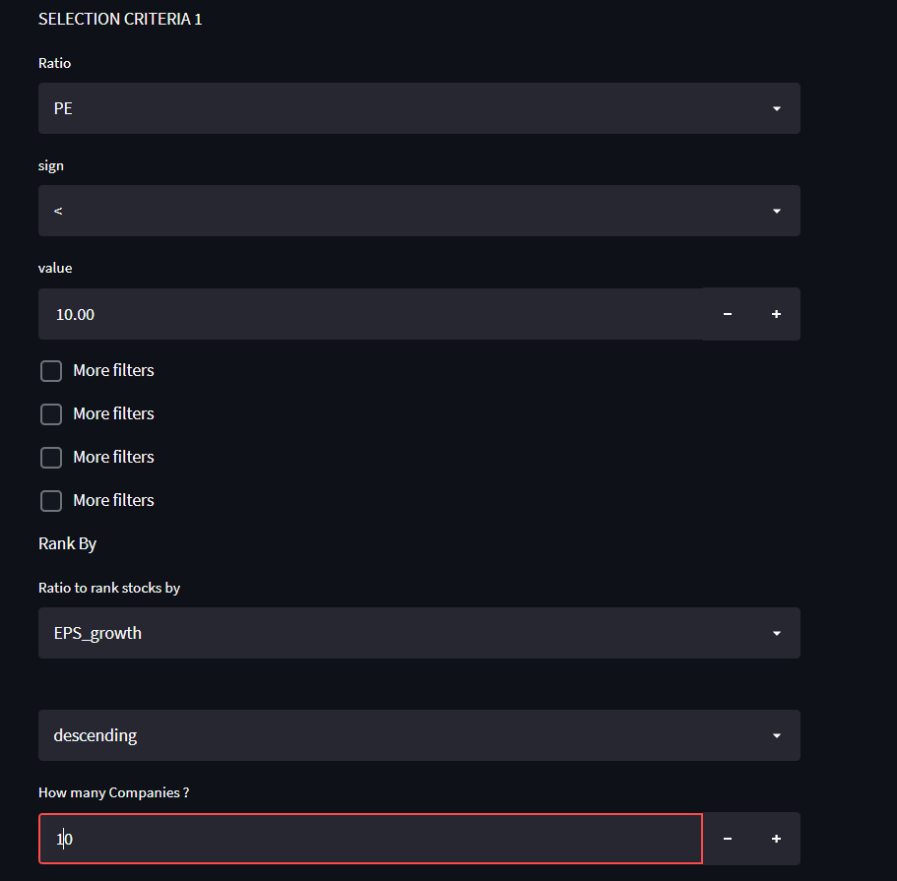

More filters (up to 5) can be added by checking the ‘More Filters’ box

The results can be interpreted as follows:

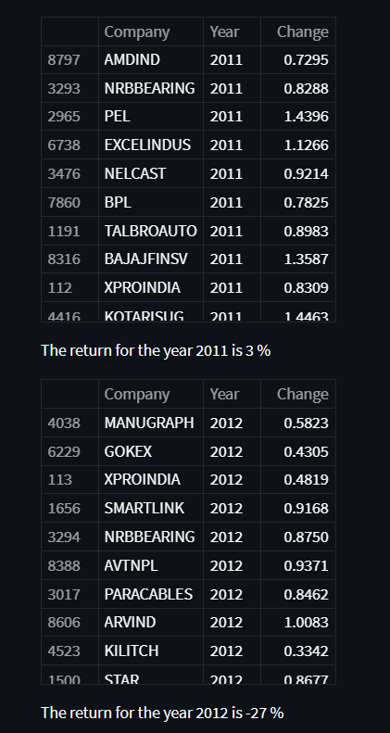

The column ‘Change’ refers to the value of 1 Rs invested in the strategy after a year.

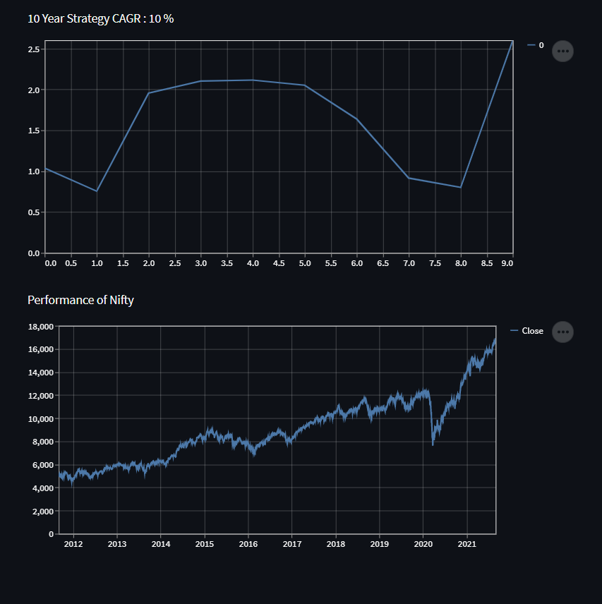

The CAGR of the strategy is presented along with the 10 year performance of Nifty.

The Graph below the CAGR shows the growth of 1 Rs invested in 2011 in the strategy.

1. **Units of the Financial Ratios and Other variables from the financial statements**
   1. **Variables with the unit of Rs:**

Start_Price (Price at the beginning of the strategy year)

Close_Price (Price at the end of the strategy year)

EPS in Rs

* 1. **Variables in Crore Rs**

Share Capital

Reserves

Borrowings

Other Liabilities

Total Liabilities

Fixed Assets

Capital Work in Progress

Investments

Other assets

Total Assets

Cash from operating activity

Cash from Investing Activity

Cash from Financing Activity

Net cash flow

Sales

Expenses

Operating Profit

Other Income

Interest

Depreciation

Profit before tax

Net profit

* 1. **Ratios**

EPS_growth (Over last 2 years)

OPM%

Tax %

Dividend Payout %

ROCE%

Change (Close Price/ Start Price)

ROE

PE

Dividend Yield

Shares Outstanding

Price to sales

1. **Strategy Description**

The strategy assumes a one-year holding period of stocks. For the year 2011, the selected stocks are bought on the first trading day of September 2011 based on the March 2011 financial ratios. The stocks are sold on the first trading day of August 2012.

The same procedure is followed for each year. (Except that stocks are bought in August in all other years)

In the graph shown in the app, changes in price within the year are not taken into consideration. Hence, no stop loss is employed.

No brokerage charge is assumed since there is only one transaction per strategy year.

1. **Data Source and Reliability**

The data has been obtained from the Annual Reports of the Respective Companies and the variables from the balance sheets, PL Statements and Cash Flow Statements have been fit into a common template. Users are requested to check the annual reports of the companies themselves to understand the ratios and variables better.

Only consolidated balance sheets are taken into account. (Companies without a consolidated Balance sheet will not take part in this screener)

The author takes no responsibility for incorrect data and investment decisions need to be made by the user only- this app merely shows how a certain strategy would have performed in the past.